**ToDo APP**

This Is Simple Spring MVC Todo App, Where Data Is Stored In Temporary Variable.

I Used Bootstrap4 , Jstl, Jsp.

The request processing workflow in Spring Web MVC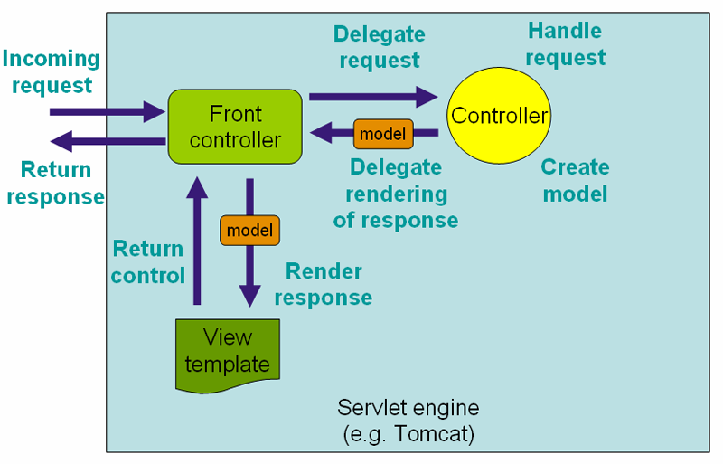

Here Are Some ScreenShots

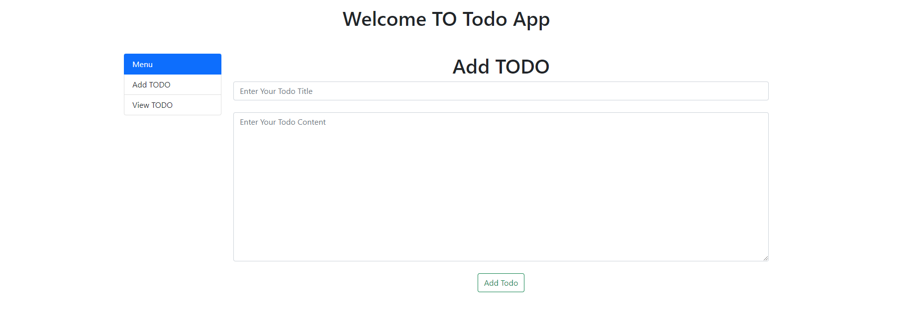

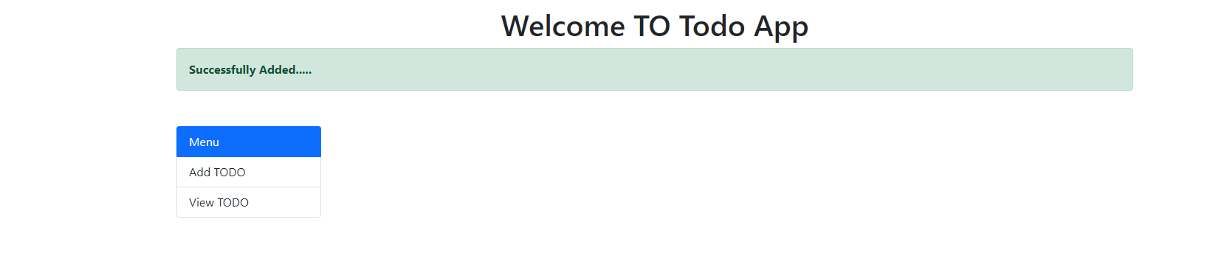

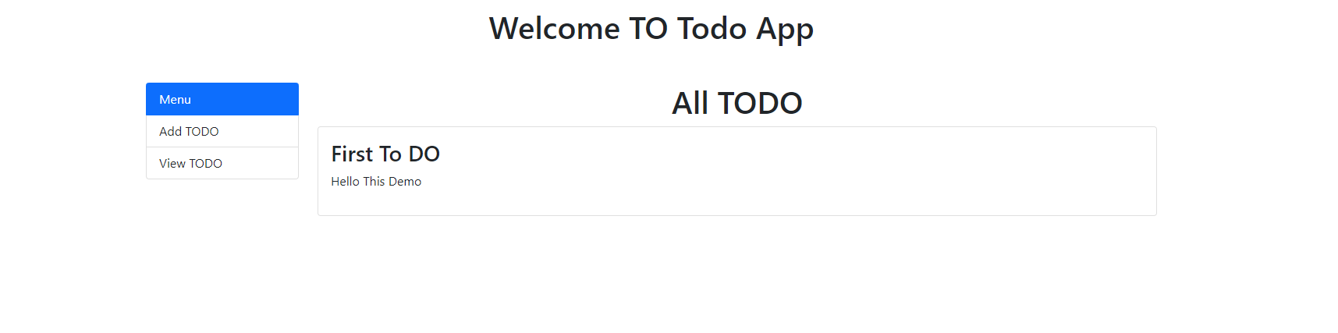

Refernce Link :- https://docs.spring.io/spring-framework/docs/4.0.x/spring-framework-reference/html/